* 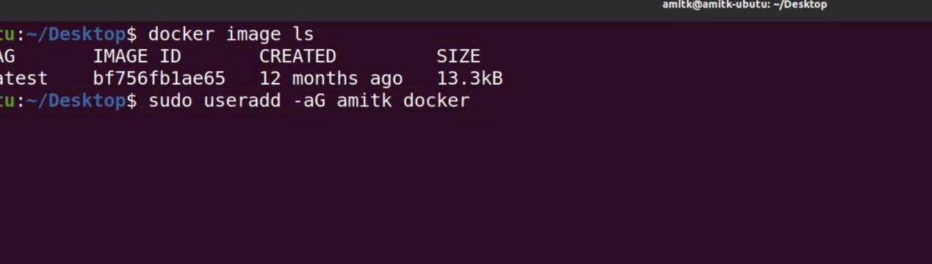
* sudo useradd -aG <username> docker
* 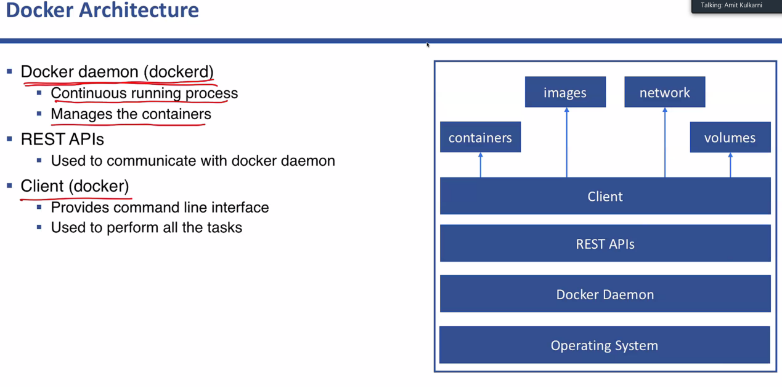
* 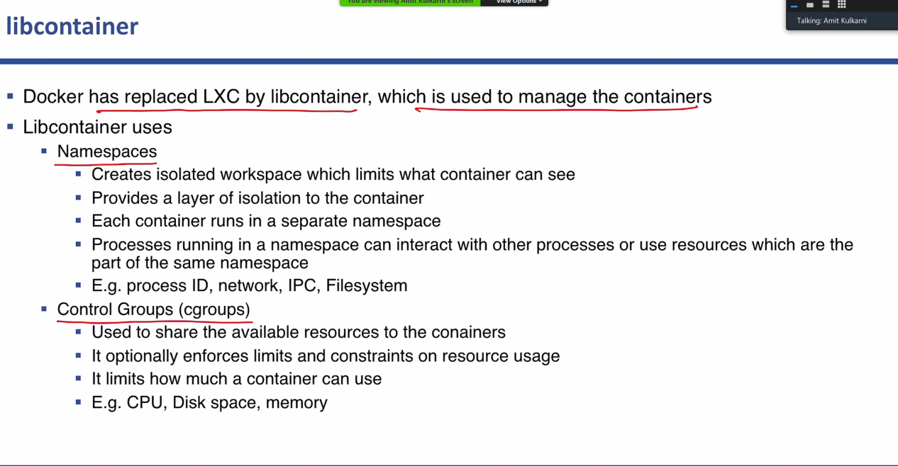

sudo add-apt-repository \"deb [arch=amd64]https://download.docker.com/linux/ubuntu \$(lsb_release -cs) \stable"

* 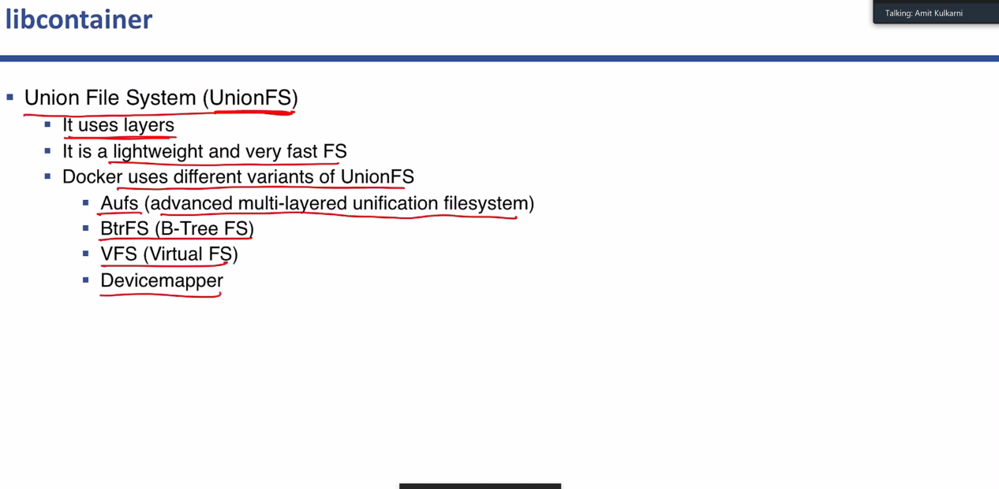
* 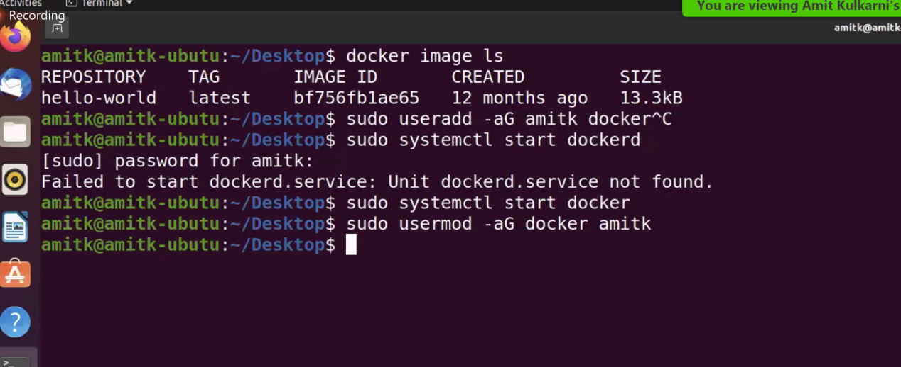
* 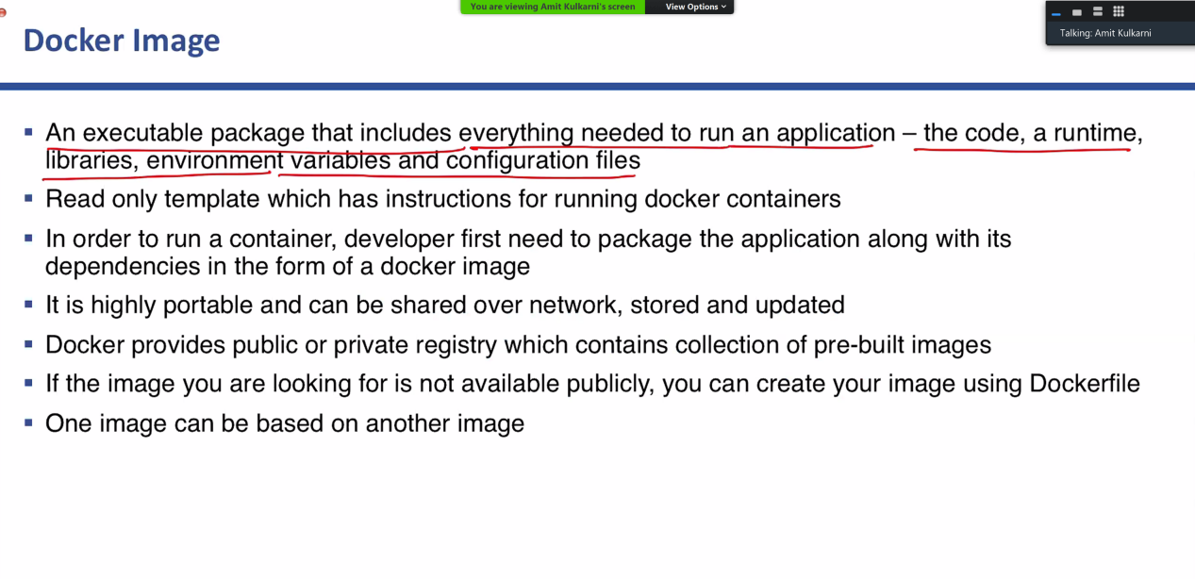

Commands:

docker image ls

docker image pull hello-world

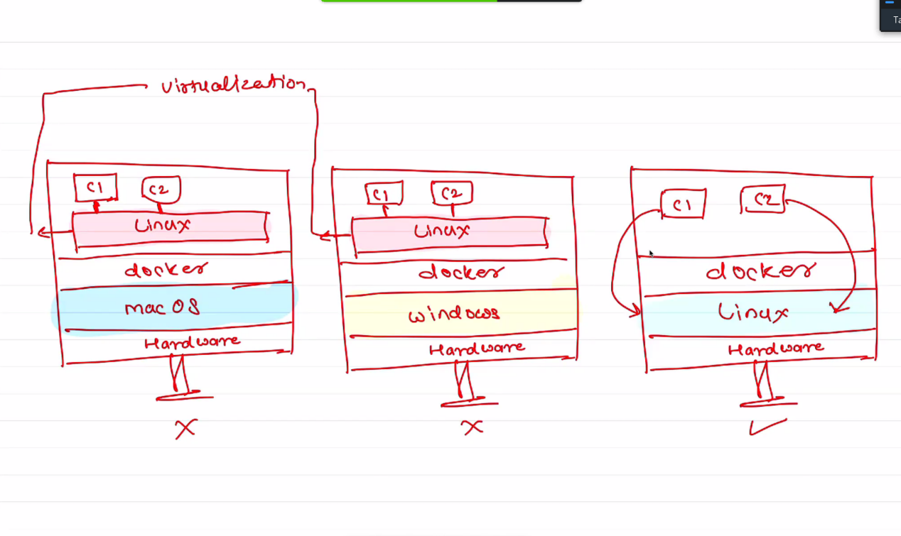

docker image inspect hello-world

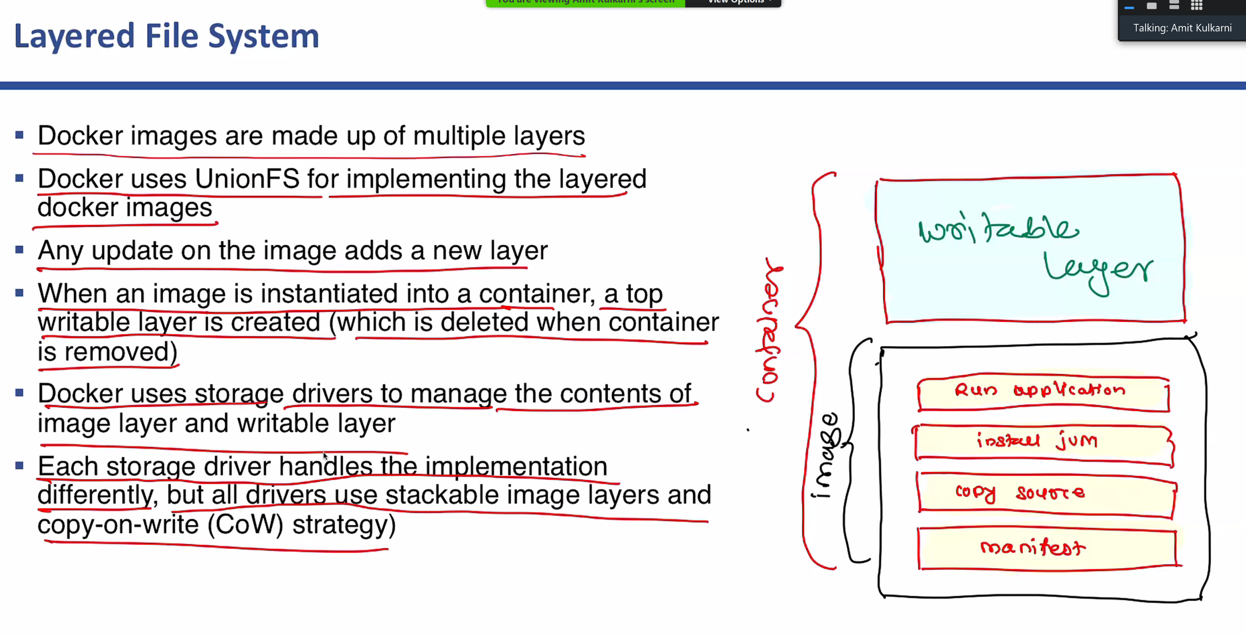

docker image rm <image_id>

Or

docker image rm <repository name>

docker container create hello-world

docker container ls -a

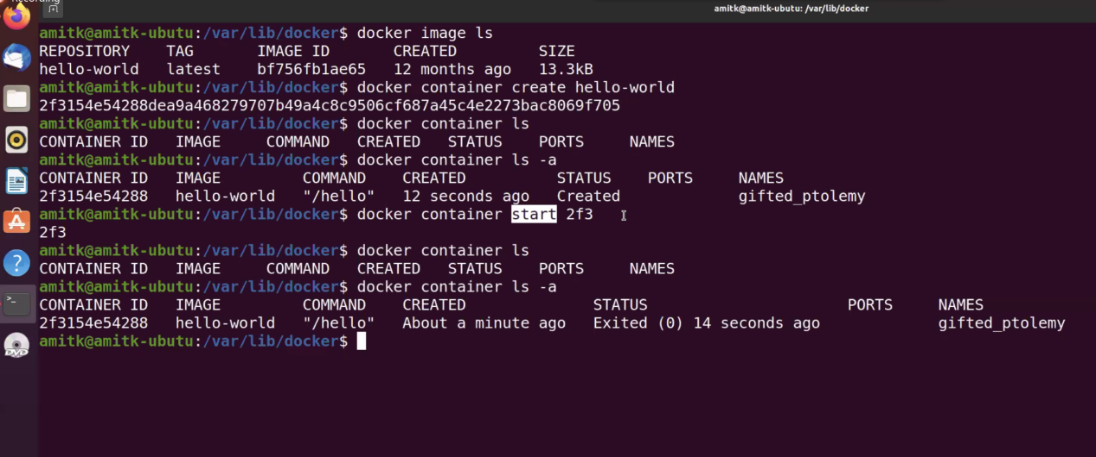

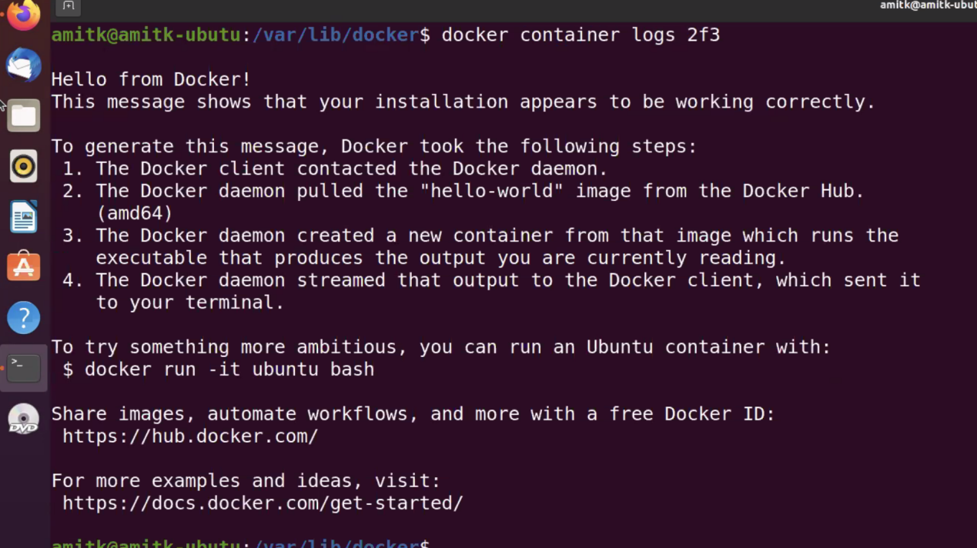

docker container run <image_name>

-Run is the combination of create and start the container

docker container rm <container_id>

-remove the container

docker container inspect <container_id>

-used to get the info about the contianer

docker conatiner logs <container_id>

-use to see the logs

Container is the running instance of the image.